**Tên: Đỗ Quốc Việt**

**Lớp: 18CNTTD**

1. **Using the MySQL SELECT statement to retrieve data from a single column example**

SELECT lastName FROM baitap1.employees;

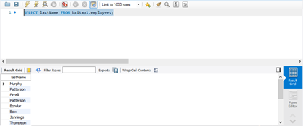

B) Using the MySQL SELECT statement to query data from multiplecolumns example

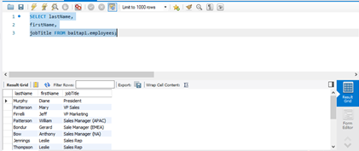

C) Using the MySQL SELECT statement to retrieve data from allcolumns example

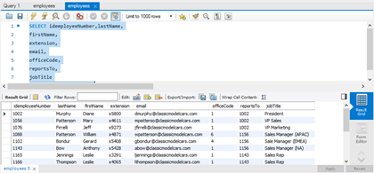

MySQL INSERT examples

1. MySQL INSERT – simple INSERT example

INSERT INTO tasks(title,priority)VALUES('Learn MySQL INSERT Statement',1);

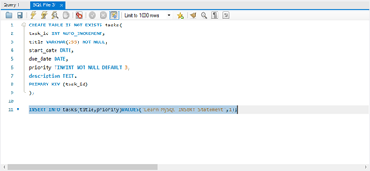

SELECT * FROM tasks;

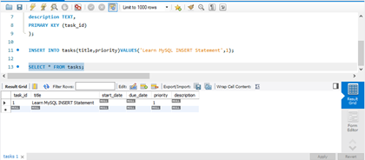

1. MySQL INSERT – Inserting rows using default value example

SELECT * FROM tasks;

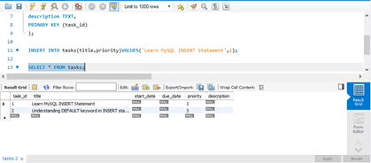

3) MySQL INSERT – Inserting dates into the table example

INSERT INTO tasks(title, start_date, due_date)VALUES('Insert date into table','2018-01-09','2018-09-15');

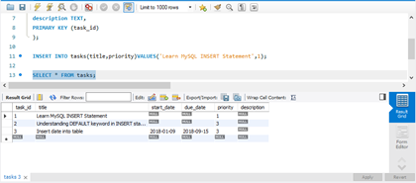

INSERT INTO tasks(title,start_date,due_date)VALUES('Use current date for the task',CURRENT_DATE(),CURRENT_DATE());

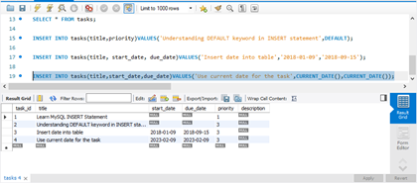

1. MySQL INSERT – Inserting multiple rows example

INSERT INTO tasks(title, priority)VALUES

('My first task', 1),

('It is the second task',2),

('This is the third task of the week',3);

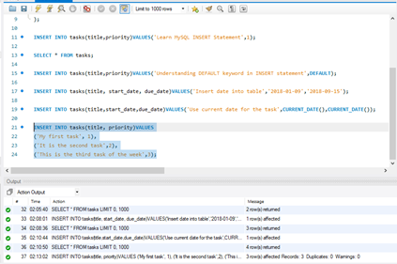

SELECT * FROM tasks;

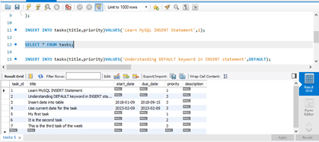

MySQL UPDATE examples

1. Using MySQL UPDATE to modify values in a single column example

SELECT firstname,lastname,email

FROM employees

WHERE idemployeeNumber = 1056;

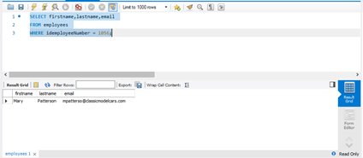

UPDATE employees SET

email = 'mary.patterson@classicmodelcars.com'WHERE

idemployeeNumber = 1056;

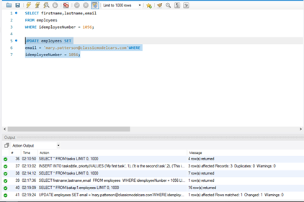

SELECT firstname,lastname,email

FROM employees

WHERE idemployeeNumber = 1056;

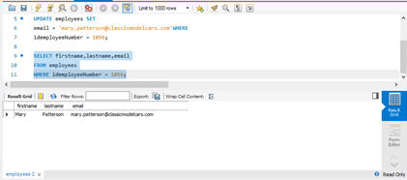

1. Using MySQL UPDATE to modify values in multiple columns

SELECT firstname,lastname,email

FROM employees

WHERE idemployeeNumber = 1056;

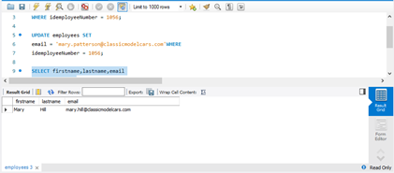

1. Using MySQL UPDATE to replace string example
2. Using MySQL UPDATE to update rows returned by a SELECT statementexample

SELECT idemployeeNumber

FROM employees

WHERE jobtitle = 'Sales Rep'ORDER BY RAND()LIMIT 1;

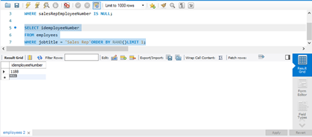

MySQL DELETE examples

MySQL DELETE and LIMIT clause

DELETE FROM customers ORDER BY customerName LIMIT 10;

